Tutorial part 1 🡪 <https://www.youtube.com/watch?v=8yjkWGRlUmY>

Tutorial part 2 🡪 https://www.youtube.com/watch?v=4dqlSk_RPmI

**Object** is basically a collection of properties which can be expressed as variables and some functions. And with that collection of information an object can represent something or whatever that thing is.

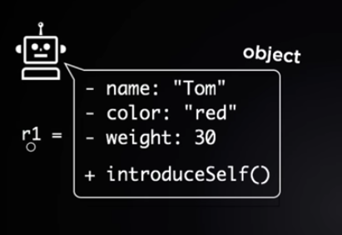

**Functions** within a object are called **METHODS**

Variables within an object are called **INSTANCE VARIABLES OR ATTRIBUTES**

**Class** is basically a blue-print from which you can make objects. Class is never referred to a particular object if not specified.

Class will take a **properties** from the object but not the values.

When creating a class you should always **name** it.

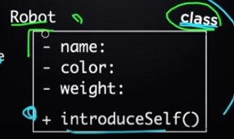

**Class Name**

**Properties**